**LAB # 02  
TASKS**

**Name: Anas Zahid  
Section: 6C  
Roll number: 2018-CS-140**

**Q1 Airport check-in and security screening business model**

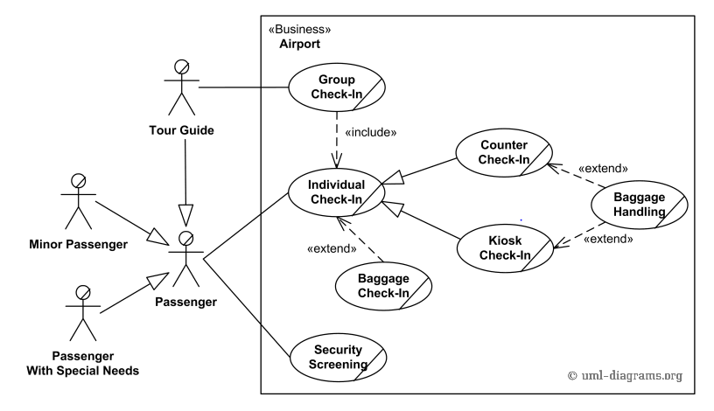

**Q2 Restaurant business model**

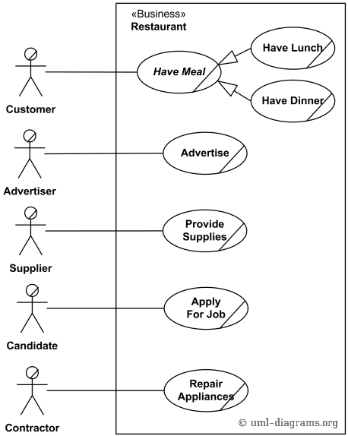

**Q3 Ticket vending machine**

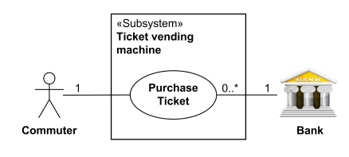

**Q4 Bank ATM UML use case diagrams examples**

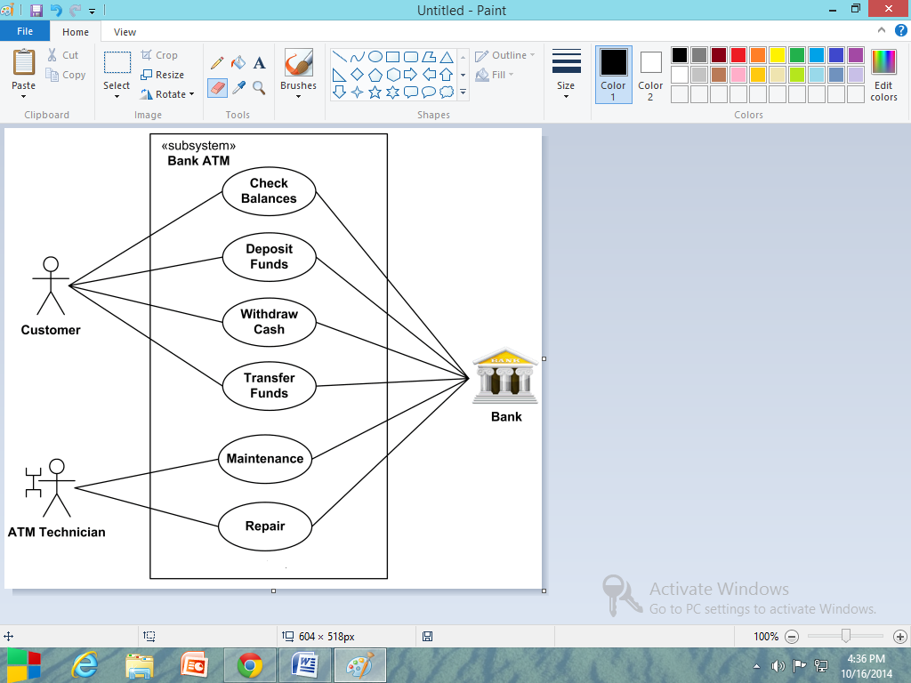

**Q5 Point of sales (POS) terminal**

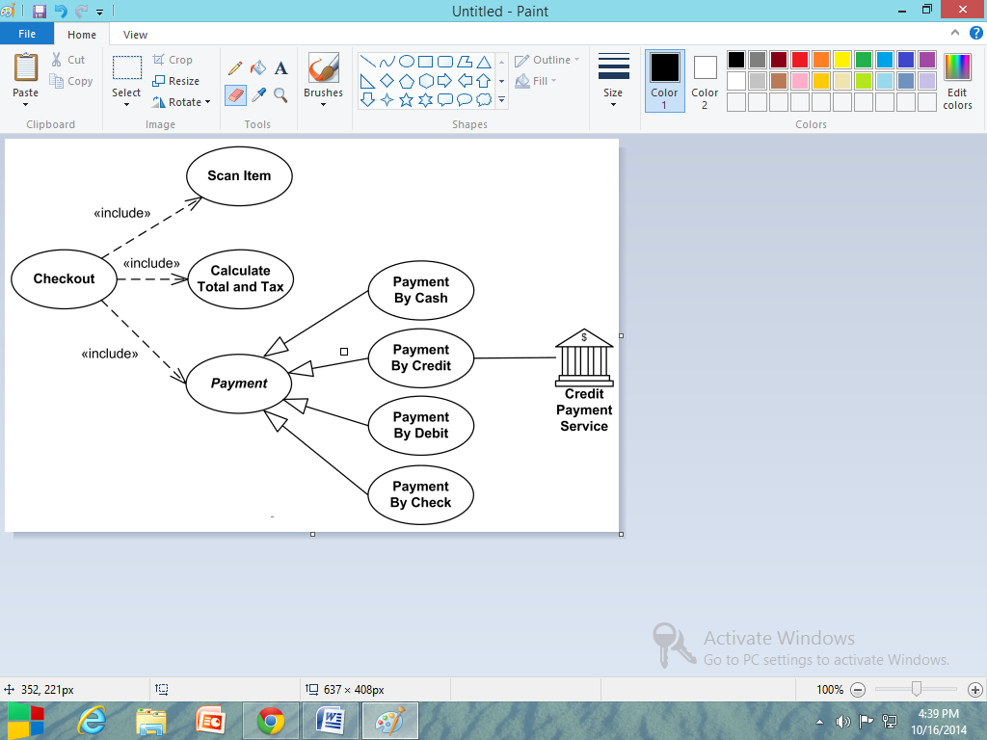

**Q6 e-Library online public access catalog (OPAC)**

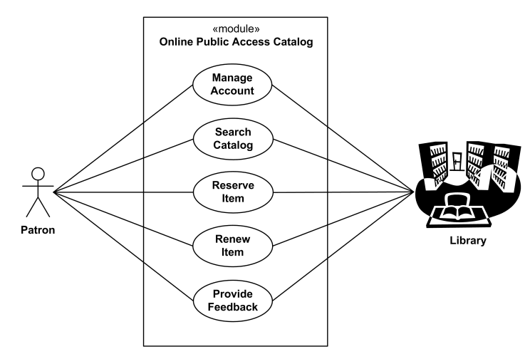

**Q7 Online shopping use case diagrams**

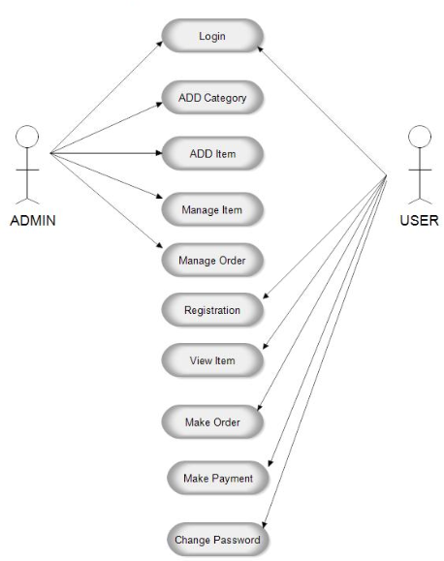

**Q8 Website administration**

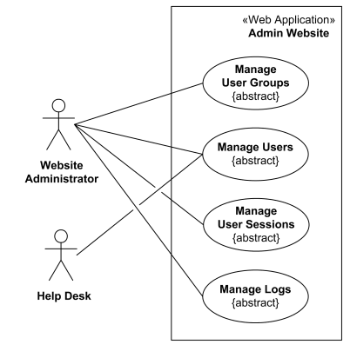

**Q9 Hospital Management**

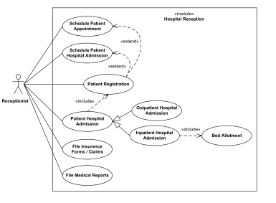

**Q10 Radiology diagnostic reporting UML use case diagram**

